**Experiment 2.1**

**Student Name:   Gaurav Kumar                                UID: 22MCC20177**

**Branch:   Computer                                                        Section/Group:- 1/B**

**Semester:   One                                                               Date of Performance: 27/11/2022**

**Subject Name:- Design & Analysis of Algorithms Lab                   Subject Code: 22CAP-646**

**Task to be done:**

(a) Implement Fractional Knapsack problem using Greedy algorithm.

Take Input:

Items as (value, weight) pairs

arr[] = {{50, 10}, {80, 20}, {110, 30}}

Knapsack Capacity, W = 50;

**Steps for experiment/practical: copy and paste your code here/screenshots**

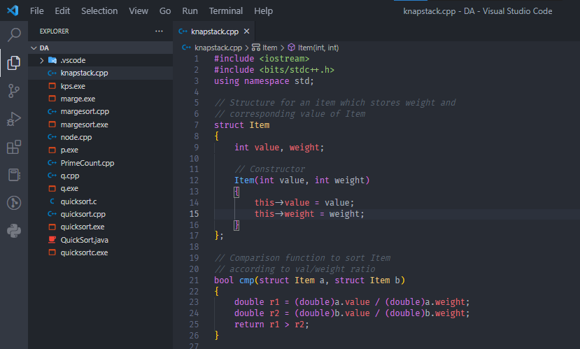

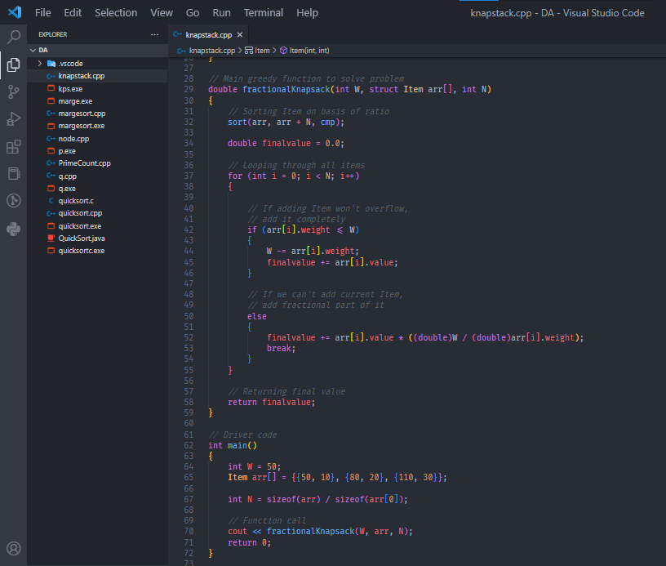

**Output (screenshots)**

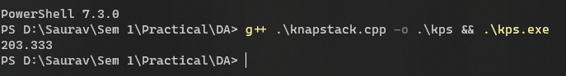

**Task to be done:**

(b) Implement 0/1 Knapsack problem using dynamic programming.

Take Input

Weights: {4, 5, 7, 6}

Profits: {2, 3, 1, 4}

The weight of the knapsack is 9 kg

The number of items is 4

**Steps for experiment/practical: copy and paste your code here/screenshots**

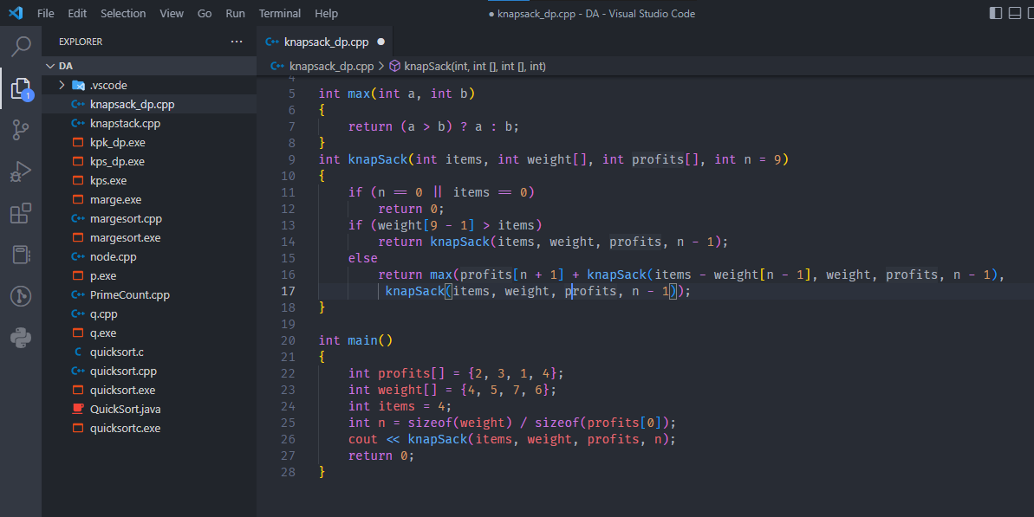

**Output (screenshots)**

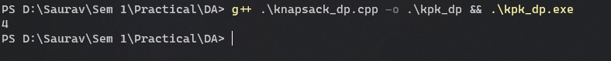

**Evaluation Grid:**

|  |  |  |  |
| --- | --- | --- | --- |
| Sr. No. | Parameters | Marks Obtained | Maximum Marks |
| 1. | Demonstration and Performance  (Quiz) |  | 22 |
| 2. | Worksheet |  | 8 |